Jared Nanoff

CWID: 894074566

CPSC 362 Software Engineering

Project Review(Still a work in progress)

**Hazard.h (Sam)**

* Hazard class header looks fully functional.

**Hazard.cpp (Sam)**

* Line 9: In the Hazard() constructor, the values of latitude and longitude are saved into integers, but saved into Position’s double values. Real latitude and longitude values can be floating values so the type should be consistent with double.
* Line 28: newpos.setLatitude() is called on both latitude and longitude. Instead, newpos.setLongitude(longitude) should be called to set the entered longitude value into the Position’s Longitude variable.
* Line 31: assignment operator will not assign the variables in Position to a new Position as desired. Operator should be overloaded within the Position class to fix this.
* Line 44: “void ::Hazard::set_radius…” There contains an extra :: after void and before Hazard.
* Line 10: Text “Enter the radius of the of the…” Delete redundant “of the.”
* Line 17: Good for single word strings, but when “oil spill” is entered, it breaks the program. Maybe using getline(cin, type); might give a better result.

**HazardAreas.h (Scott)**

* HazardAreas class header looks fully functional.

**HazardArea.cpp (Scott)**

* 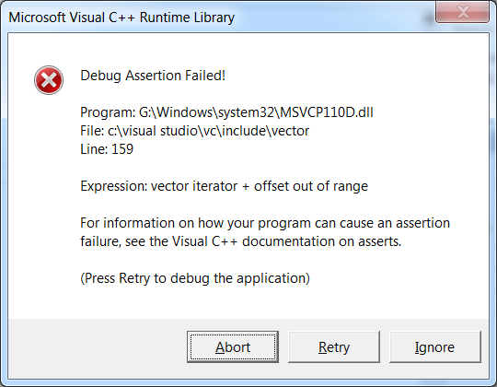
* .deleteHazard() currently breaks the program.
* Line 54: when traverse is 0, you are adding -1 to it. list.begin() + (0-1).
* Line 54: list.begin() points to the first element of type Hazard in the vector and will not take an added value. Try calling outside of the parameters to get the beginning element and then traversing through.

**Main.cpp (Skyler)**

* Line 9: Some sort of signifier should separate the difference in hazard data you are entering in the .addHazard loop. Just something like cout << “Hazard “ << i+1 <<”: \n” ; at the top of the loop.
* Line 13: Have a user input and create more instances of Hazard to search through. Currently, it looks for the first element (ID starts at 1000). In order to test the .searchHazards() thoroughly, it should traverse through the vector.